**CHEMISTRY LAB: FLAME TEST FOR METALS**

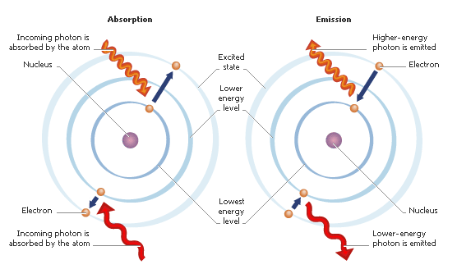

**Background**

Chemists began studying colored flames in the 18th century and soon used “flame tests” to distinguish between some elements. Different elements burn with different colored flames. Although some of the flames you will be seeing appear similar in color, their light can be separated with a prism into distinctly different bands of color on the electromagnetic spectrum. These bands are called atomic line spectra, and they are unique to each element.

Niels Bohr studied the line spectrum for hydrogen, and wondered what the specific line spectrum had to do with the structure of the atom. He postulated that an electron could have only specific energy values in an atom, which are called energy levels. Bohr believed that the energy levels for electrons were quantized, meaning only certain, specific levels were possible.

How does an electron move between energy levels? By gaining the right amount of energy, an electron can move, or undergo a transition, from one energy level to the next. The emission of light by atoms to give the line spectrum is as follows

* An electron in a high energy level undergoes a transition to a low energy level.
* In this process, the electron loses energy, which is emitted as a photon
* The energy difference between the high energy level and the low energy level is related to the frequency (color) of the emitted light.

**Pre-lab Questions *Read p. 138 – 143 in your text and answer questions in complete sentences.***

1. What happens to an electron when energy is added?
2. What is released when an electron loses energy?
3. What determine the frequency (color) of photons?
4. Is the excited state of an electron stable or unstable?
5. Can an electron exist between energy levels according to Bohr’s model of the atom?
6. Describe the cause of atomic emission spectrum of an element.
7. How is the change in electron energy related to the frequency of light emitted in atomic transitions?
8. List the colors of the visible spectrum in order of INCREASING wavelength.
9. What color of light in the visible spectrum has the most energy?
10. What color of light in the visible spectrum has the least energy?
11. What happens when a hydrogen atom absorbs a quantum of energy?

**Purpose**

* Observe the colors emitted by various metal ions
* Identify metals through flame test
* Identify an unknown metal or narrow down the possibilities for the identity by means of its flame color.

**Safety**

* Goggles and aprons must be worn at all times since fire and chemicals are being used
* Observe proper handling of the chemicals
* Observe all safety procedures for working with open flames

**Procedure**

* 1. Retrieve goggles and lab apron. These must be worn at all stations with chemicals and fire.
  2. You will rotate through various stations:
     + Observing atomic emission spectra (Part I and II)
       - Part I – White light: Sunlight or Incandescent light
       - Part II – Gas spectra
       - Note the similarities and differences in the various spectra observed.
     + For the solutions
       - Light Bunsen burner
       - Place the looped end of the wire in the solution
       - Hold the looped end in the flame
       - Note the color of the flame produced
     + Teacher Demonstration: Copper metal

**Data:**

Write your observations for the emissions spectra you observed below:

**White Light:**

**Gas Spectra:**

**Record the color of your flame in the data table. Be descriptive.**

|  |  |  |
| --- | --- | --- |
| **Formula** | **Substance Name** | **Flame Color** |
| Na2CO3 | Sodium carbonate |  |
| KNO3 | Potassium nitrate |  |
| Cu(NO3)2 | Copper II nitrate |  |
| Sr(NO3)2 | Strontium nitrate |  |
| KCl | Potassium chloride |  |
| NaCl | Sodium chloride |  |
| CuSO4 | Copper II Sulfate |  |
| SrCl2 | Strontium chloride |  |
| NaNO3 | Sodium nitrate |  |
| CuCl2 | Copper II chloride |  |
| K2SO4 | Potassium sulfate |  |
| Unknown | ------------------------------------------- |  |

**Questions and Analyses (answer in complete sentences)**

1. Group the substances based on the flame colors produced.
2. What patterns do you notice in the groupings?
3. Predict the flame color for a substance called strontium sulfate. **Explain your reasoning.**
4. What evidence do you have that atoms of certain elements produce a flame of a specific color?
5. Can a flame test be used to identify a metal atom in a compound? Why or why not? What about a non-metal atom?
6. Copper oxide, CuO, is a black solid. It doesn’t look at all like the element copper. What color flame would it produce? Explain
7. Compare the spectra of the two gases your observed – How are they the same? How were they different?
8. Compare the spectra of the two gases to the spectrum of the white light. How are they the same? Different?
9. Define continuous and discreet spectra
10. How does a discreet spectrum support Bohr’s idea of electrons existing only at discreet energies?
11. Aerial fireworks contain gunpowder and chemicals that produce colors. What elements would you include to produce the following colors?
    1. Crimson red b. Orange
12. Name the element you believe you observed. You must support this decision based on your data and observation – explain how you came to this decision. Also, discuss errors which could have occurred and why your answer may not be correct.